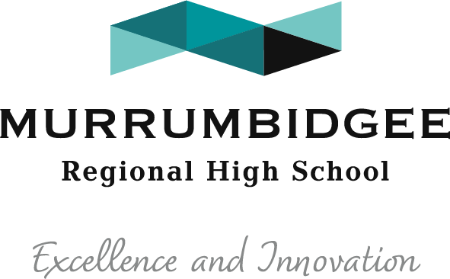

How to access Google Classroom via student portal

- Open any browser
- Go to education.nsw.gov.au
- Log in – Student Portal
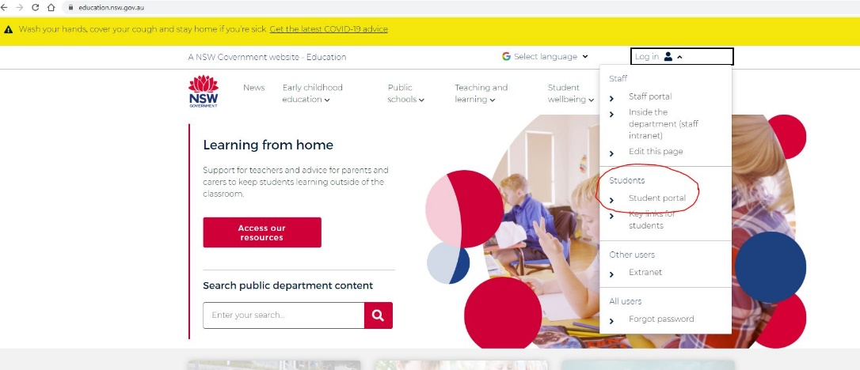

- Log in using Student ID (firstname.lastname) and DoE student password
- Go to Learning> Show More > GSuite (Google Apps for Education)
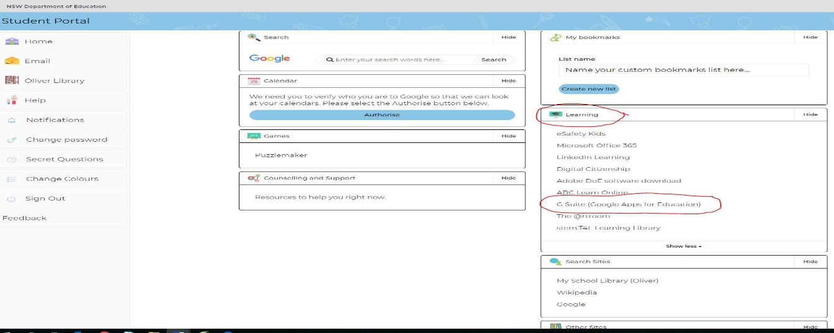

Go to Google Classroom
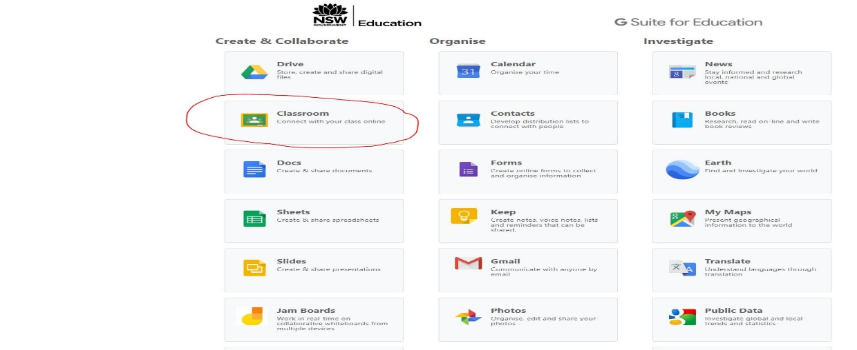

Students can email the school at Murrumbidgee-h.school@det.nsw.edu.au if they have forgotten their password.

