Educational Websites and Resources
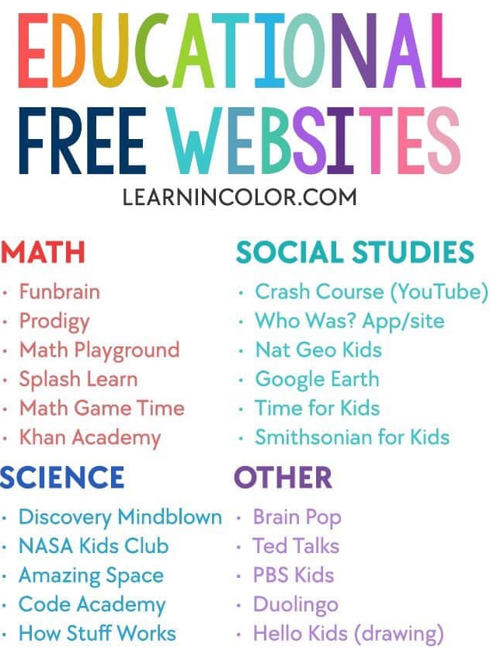
Online resources:
- BrainPop
- Curiosity Stream
- Tynker
- Outschool
- Udemy
- iReady
- Beast Academy (Math)
- Khan Academy
- Creative Bug
- Discovery Education

YouTube Channels:
- Crash Course Kids
- Science Channel
- SciShow Kids
- National Geographic Kids
- Free School
- Geography Focus
- TheBrainScoop
- SciShow
- Kids Learning Tube
- Geeek Gurl Diaries
- Mike Likes Science
- Science Max
- SoulPancake

Lots of board games, library books (and Kindle), tinkering/upcycling with household junk, etc.
Some resources to help with kids at home:

*Scholastic has created a free learn-from-home site with 20+ days of learning and activities.

https://classroommagazines.scholastic.com/…/learnathome.html

*Pretend to travel the world..Go on a virtual tour of these 12 famous museums.

https://www.travelandleisure.com/…/museums-with-virtual-tou…

*This is the awesome free curriculum that we use. Everything from preschool activities to 12th grade is here!

https://allinonehomeschool.com/

*List of thinking games by grade: https://allinonehomeschool.com/thinking/

**More awesome free learning websites that we like to use**

https://www.starfall.com/h/

https://www.abcya.com/

https://www.funbrain.com/

https://www.splashlearn.com/

https://www.storylineonline.net/

https://pbskids.org/

https://www.highlightskids.com/

https://kids.nationalgeographic.com/

https://www.coolmath4kids.com/

http://www.mathgametime.com/

https://www.uniteforliteracy.com/

http://www.literactive.com/Home/index.asp

http://www.sciencekids.co.nz/

https://www.switchzoo.com/

https://www.seussville.com/

https://www.turtlediary.com/

https://www.e-learningforkids.org/

https://classroommagazines.scholastic.com/support/learnathome.html

http://www.scholastic.com/teachers/story-starters/

http://www.khanacademy.org

https://education.abc.net.au/home#!/home

https://sydneylivingmuseums.com.au/stories-histories

https://world-geography-games.com/

https://ed.ted.com/lessons

https://www.storylineonline.net/library/ - primary

https://www.abc.net.au/btn/

https://kinderart.com/art-lessons/painting/teaching-art-at-home/

https://www.artbarblog.com/face-the-foliage-inspired-flower-portraits-with-kids/

https://www.mirartit.com/​

http://studyladder.com.au

